Coffee Maker Quest

Mark Shanoudy & Dan Mahoney

CS 1699 – DELIVERABLE 2: Unit Testing and Code Coverage

The main issue faced when writing these unit tests was how to approach writing a test for the getDescription method. The test was implemented by comparing what the expected description string would be (as derived by manual tracing) against the description string generated by the getDescription method. This test failed because of how the private method, generateDescription, is currently implemented. generateDescription makes use of a static global variable named _pseudoRand to keep track of the index of used adjectives/nouns in each Room description. Because _pseudoRand is static, it would make it impossible for the current test to pass if the number of calls to generateDescription would ever change—as would likely happen if any tests were to be added or removed from the test suite. Due to this difficulty, and our inability to find a workaround, the test, testGetDescription, is currently ignored when running the test suite.

The only active test that failed was the test to verify case-insensitivity of the move North command. This test is failing because of a coding error found in the doSomething method in the Game class.

<https://github.com/mshanoudy/deliverable2_repo>

# Unit Test Output

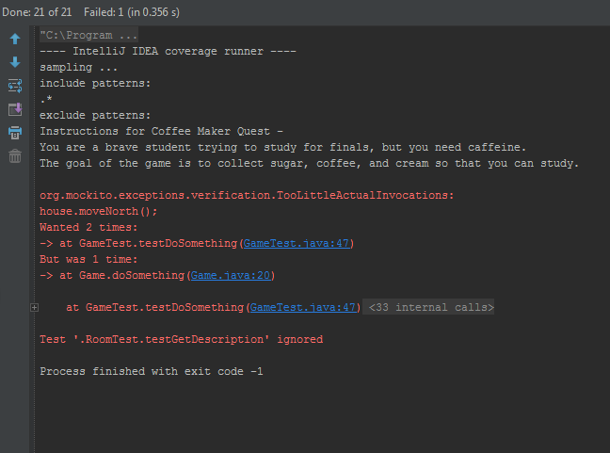

# Code Coverage Output

